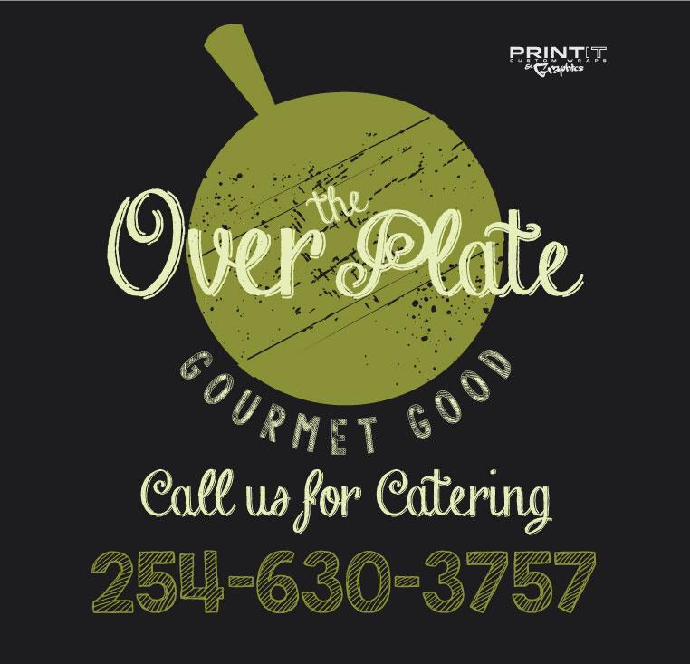

Considering Food Truck Catering?

Food truck catering provides consumers with a hip, quick, affordable and delicious alternative to traditional catering providers.
Fill in the inquiry form below and email it to us. (overtheplatecatering@gmail.com) and we will contact you as soon as possible!

Name:
Email:
Type of Event:
Date of Event:
Time of Event:
Location:
How many attendees do you expect?
Is Parking large enough for 22ft. Truck?
Food will be paid for by:
Menu: (Please refer to the link on our website for Food Truck Menu Options)
Any special requests?

